Assignment 2
Q1
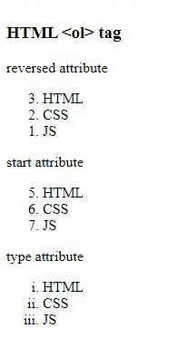
<!DOCTYPE html>
<html lang="en">
<head>
<meta charset="UTF-8">
<meta name="viewport" content="width=device-width, initial-scale=1.0">
<title>Ass_2_1</title>
</head>
<body>
<h3>HTML &lt;/ol&gt; tag</h3><br>
reversed attribute <br>
<ol reversed>
<li>HTML</li>
<li>CSS</li>
<li>JS</li>
</ol>

Start attribute
<ol type="5">
<li>HTML</li>
<li>CSS</li>
<li>JS</li>
</ol>
type attribute
<ol type="i">
<li>HTML</li>
<li>CSS</li>
<li>JS</li>
</ol>
</body>
</html>
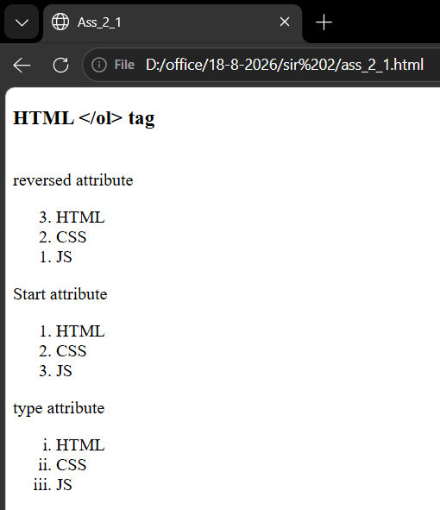

Q 2
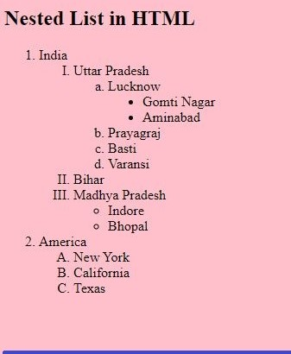
<!DOCTYPE html>
<html lang="en">
<head>
<meta charset="UTF-8">
<meta name="viewport" content="width=device-width, initial-scale=1.0">
<title>ass_2_2</title>
</head>
<body style="background-color: rgb(221, 139, 228);">
<h3>Nested List in HTML</h3>
<ol>
<li>India</li>
<ol type="I">
<li>Uttar Pradesh</li>
<ol type="a">
<li>Lucknow</li>
<ul>
<li>Gomti Nagar</li>
<li>Aminabad</li>
</ul>
<li>Prayagraj</li>
<li>Basti</li>
<li>Varansi</li>
</ol>
<li>Bihar</li>
<li>MAdhya Pradesh</li>
<ul type="disk">
<li>Indor</li>
<li>Bhopal</li>
</ul>
</ol>
<li>America</li>
<ol type="A">
<li>New York</li>
<li>Califonia</li>
<li>Texas</li>
</ol>
</ol>
</body>
</html>
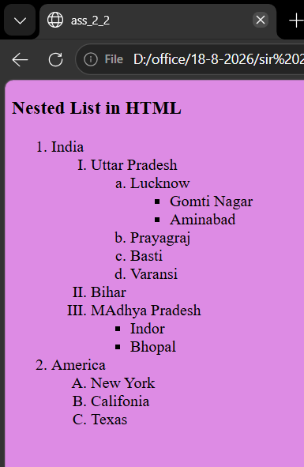

Q3

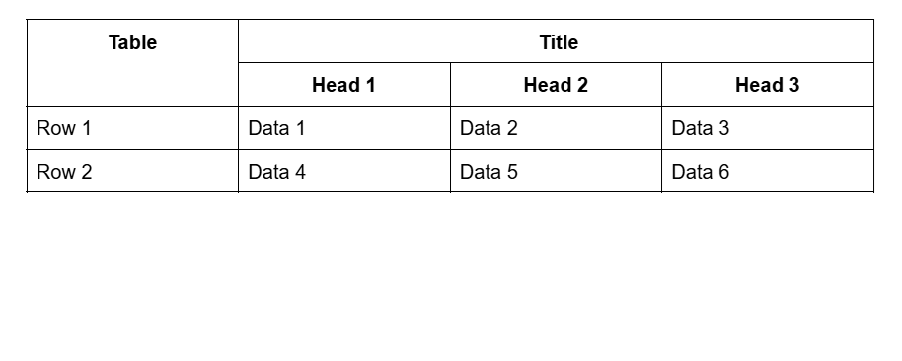
<!DOCTYPE html>
<html lang="en">
<head>
<meta charset="UTF-8">
<meta name="viewport" content="width=device-width, initial-scale=1.0">
<title>Document</title>
<style>
table {
border-collapse: collapse;
border: 2px solid black;
}
td {
border: 1px solid black;
padding: 10px;
}
</style>
</head>
<body>
<table>
<tr>
<td rowspan="2"><b>Table</b></td>
<td colspan="3" style="text-align: center;"><b>Title</b></td>
</tr>
<tr>
<td><b>Head 1</b></td>
<td><b>Head 2</b></td>
<td><b>Head 3</b></td>
</tr>
<tr>
<td>Row 1</td>
<td>Data 1</td>
<td>Data 2</td>
<td>Data 3 </td>
</tr>
<tr>
<td>Row 2</td>
<td>Data 4</td>
<td>Data 5</td>
<td>Data 6</td>
</tr>
</table>
</body>
</html>
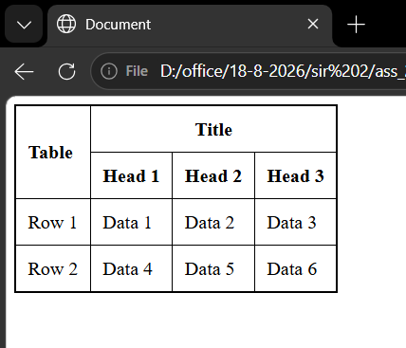
Q 4

<!DOCTYPE html>
<html lang="en">
<head>
<meta charset="UTF-8">
<meta name="viewport" content="width=device-width, initial-scale=1.0">
<title>Document</title>
<style>
table {
border-collapse: collapse;
border: 2px solid black;
}
td {
border: 1px solid black;
padding: 10px;
}
</style>
</head>
<body>
<table>
<tr>
<td rowspan="2"><b>Table</b></td>
<td colspan="3" style="text-align: center;"><b>Title</b></td>
</tr>
<tr>
<td><b>Head 1</b></td>
<td><b>Head 2</b></td>
<td><b>Head 3</b></td>
</tr>
<tr>
<td>Row 1</td>
<td>Data 1</td>
<td>Data 2</td>
<td>Data 3 </td>
</tr>
<tr>
<td>Row 2</td>
<td>Data 4</td>
<td>Data 5</td>
<td>Data 6</td>
</tr>
</table>
</body>
</html>

